Student Guide for Submitting

Credit for Prior Learning Evaluation Requests

Purpose:
This procedure outlines the steps for students to submit a Nonacademic E-Form when requesting Credit for Prior Learning (CPL), including how requests are reviewed, and how credit is applied.

Procedure
- Contact Advisor
  - Meet with Advisor to discuss opportunities and eligibility for Credit for Prior Learning

Access SOAR Account
  - Navigate to the SOAR login page.
  - Enter your username and password to access your student account.

Navigate to the Non-academic E-Form
  - Once logged in, navigate to the “Student Help” tile to begin your submission
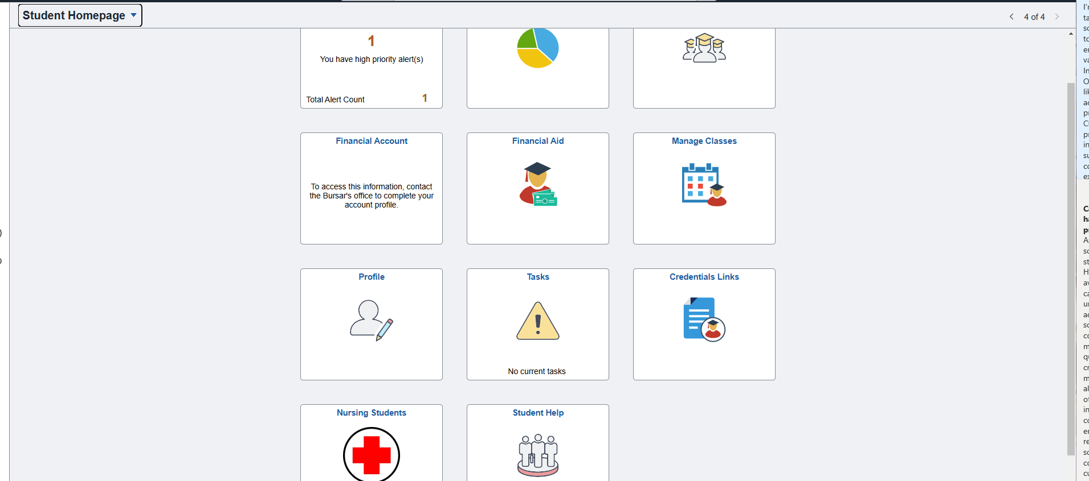

Access E-Forms
  - Once you are in the “Student Help” section, you will navigate to “Student eForms” and select “Student Records- Non-Academic Evaluation Credit”

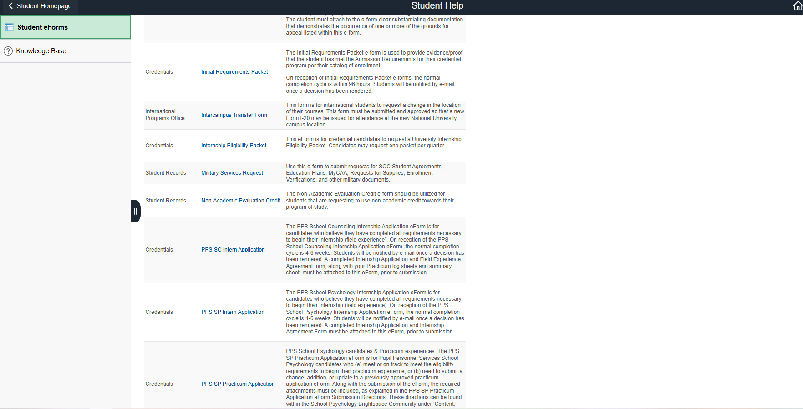
  - This will bring you to the CPL submission form. Please read through the information, check the acknowledgement statement, and select “Continue to e-form”.
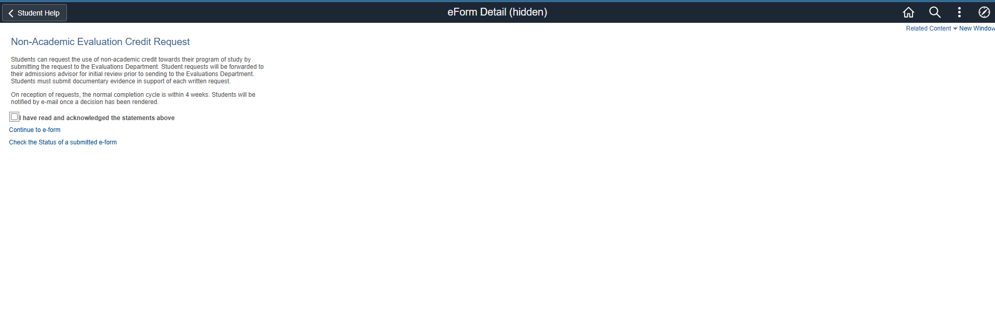

Select Request Type

This will open the NAE form and the existing prior learning opportunities. Read through this carefully and navigate to the bottom of the page to “Request Detail”.

Select Request Type” and locate the appropriate opportunity you are seeking credit for.

If your experience is not listed, please select “Prior Learning Assessment” (see below).
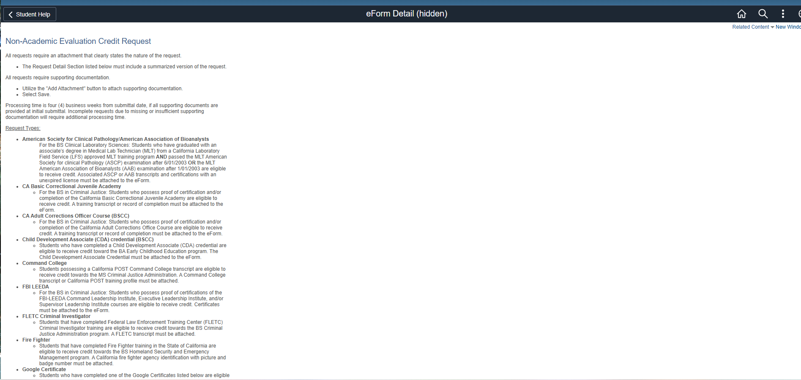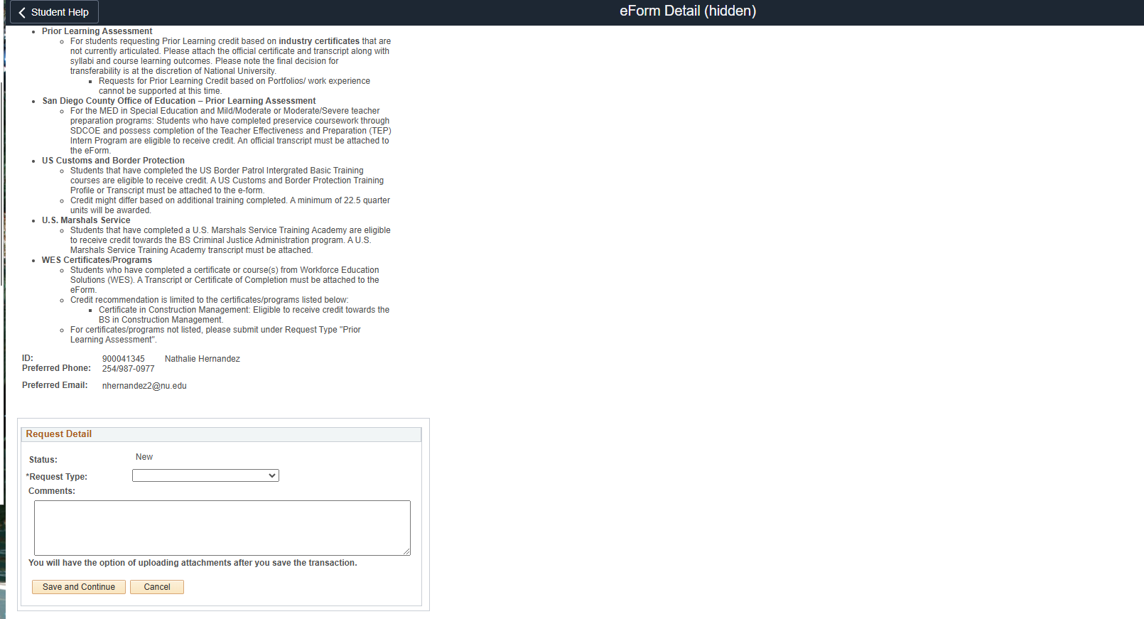
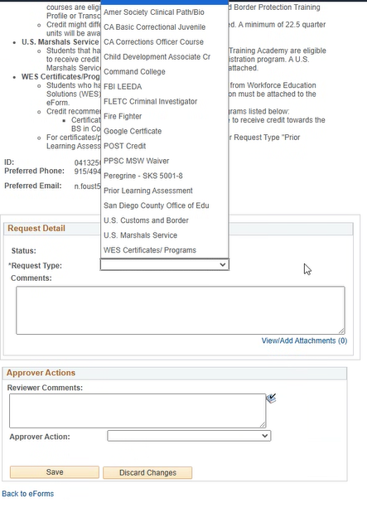

Add Comments
  - In the Comments ﬁeld, provide additional details or context for your request, including speciﬁcs about your training or certiﬁcation if entered manually.
    - Comments may include information about where and when the learning experience was completed, what documentation you are providing, explanation of learning experience, or any other information that may be relevant to your submission.

Save and Continue
  - Once you have selected the appropriate request type and completed the comments section, click Save and Continue.
  - You will have the option to upload attachments after saving the transaction. Ensure all necessary documentation is attached to support your request.
    - Documentation may include transcripts, certiﬁcations, licenses, certiﬁcates of completion, test results, employer records, etc.
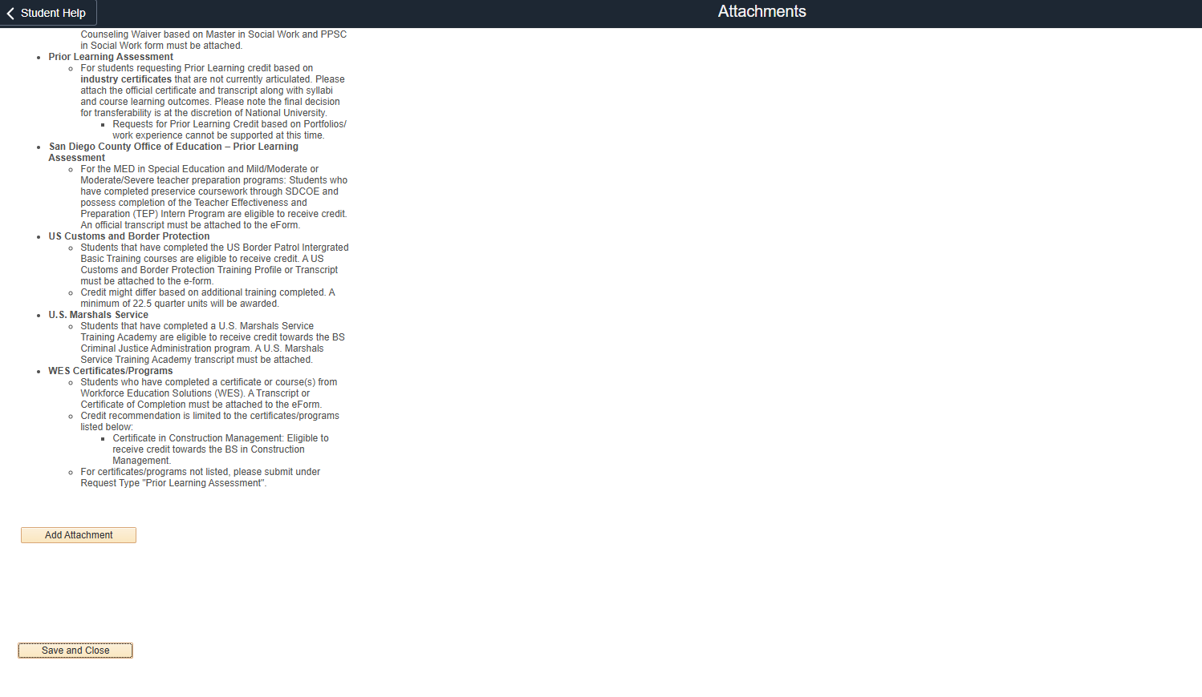
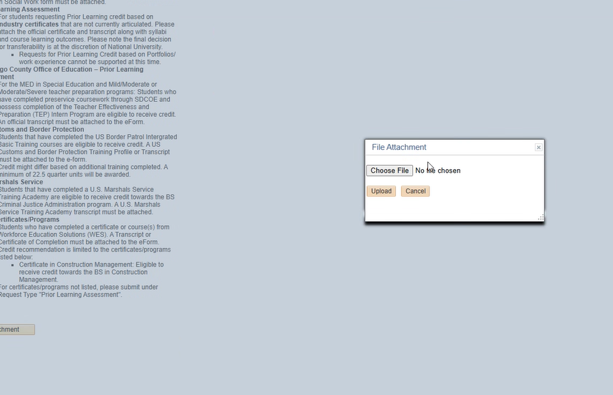

Submit the Application
- Select “Save and Close” and then “Submit”
- You will receive a pop-up message that looks like this:
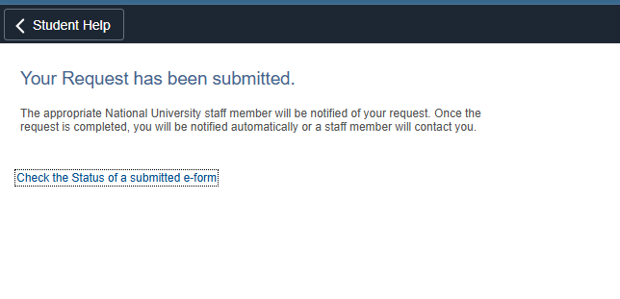

Note: The application review and approval process may take 4 to 6 weeks. The Registrar’s Office will contact the student if additional information is required.
- You may check the status of your e-form but selecting the “Check the Status of a submitted e-form” above.
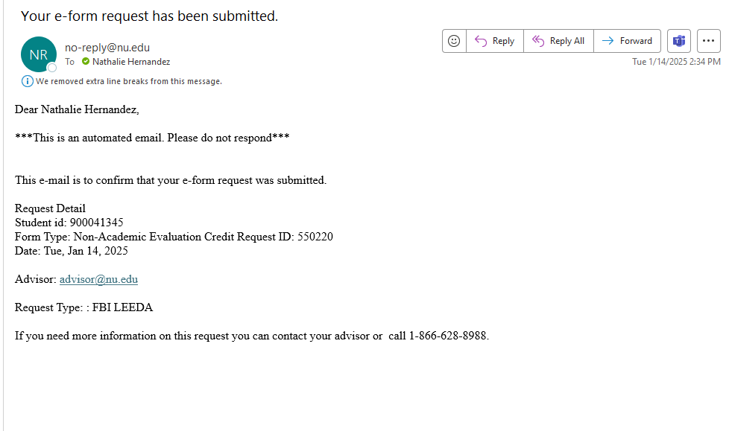
- You will receive an email, like the one below, confirming that your request has been submitted

Final Review and Decision
  - The Registrar's Office will review the request and consult with appropriate
faculty, if necessary
  - The student will be informed of the ﬁnal decision regarding their request from the Registrar’s Office via email
  - If the CPL evaluation request is approved, the Registrar’s Office will post any awarded credit to the student’s account
  - The credit will then be reﬂected on the student’s National University
transcript

Appeals
  - If the student is not satisﬁed with the result of their CPL request, they may appeal the decision.
  - For more information on appeals, please visit: Student Appeals Procedure.

Important Notes
- Ensure all required ﬁelds are ﬁlled out and documentation is attached to avoid
delays in processing.
- If assistance is needed, contact the SOAR Help Desk or the Registrar’s Office

