Appendix B
PART 1. GENERAL INFORMATION TO BE PROVIDED BY ALL PROGRAMS
- 1. Institution Name National University

- 2. Dean or Director of Teacher Education Name and contact information:
Dr. Susanne James, Chair Special Education Department- sjames2@nu.edu

3. Primary contact(s) for questions and subsequent follow-up communications from the Commission regarding the literacy certification process.
Dr. Patricia Heydet-Kirsch Director of Assessment, Accreditation, and Clinical Practice. pheydetkirsch@nu.edu

4. Credential program type addressed in this document-

Preliminary Education Specialist: Extensive Support Needs
Preliminary Education Specialist: Mild to Moderate Support Needs

5. List of all pathways offered by the institution for this credential (e.g. student teaching traditional, intern, residency).
Student Teaching, Internship, and Residency Options are available to candidates.

6. Affirmation by the Dean or Director of Teacher Education of the following statements:
I have read the materials being submitted and authorize their submission for the purposes of certification pursuant to SB 488 (Chapter 678, Statutes of 2021).

I understand that what is included in this submission process represents selected aspects of the new literacy standard adopted by the Commission. I understand that the information submitted represents the information specifically required for literacy certification as indicated in Education Code section 44259(B) (4)(A) and (B).

I understand that all Preliminary Multiple Subject, Single Subject, Education Specialist, and PK-3 ECE Specialist Instruction Credential programs must be fully aligned with all the applicable literacy instruction standards and TPEs, not just those required for certification, by July 1, 2024. I further attest that the program and all associated pathways represented in this submission have undergone a full review by our faculty and staff and are, or will be, fully aligned to the new literacy instruction standard by July 1, 2024.

I understand that beginning July 1, 2025, all Preliminary Multiple Subject, Education Specialist, and PK-3 ECE Specialist Instruction credential candidates will be required to take and pass a Commission-approved Literacy Performance Assessment that is embedded in the program pursuant to Education Code 44320.3 and is based on the literacy instruction standard and TPE Domain 7.

Yes,
Dr. Susanne James, Chair, Special Education Department

PART 2. OVERVIEW OF REQUIRED COURSES FOR LITERACY INSTRUCTION AND PROCESS FOR PROGRAM REVISIONS
Table 2.1
Credential Pathway | Required Courses (primary) | Courses with TPE 7 included
Narrative: Literacy instruction is threaded throughout the Extensive Support Needs credential program so that teacher candidates gain foundational understanding of literacy instruction while practicing and applying TPEs as they progress through their credential program. Faculty reviewed all TPEs and aligned course content with Standard 7 across specific courses. The course leads (listed in table 2.2) of classes with integrated Standard 7 content have revised syllabi and courses so that all Standard 7 TPEs will be taught beginning Spring 2025. If a course lead is not teaching the course, PT faculty receive mentorship in quarterly meetings and support when teaching that section to ensure that the Standard TPEs are embedded.
Educational Specialist Extensive Support Needs  Educational Specialist Mild /Moderate Support. Needs | SED 607 Language & Literacy Basics  SED 609 Language & Literacy Case Studies | SED 601 Special Education Foundations  SED 605 Classroom & Behavior Management  SED 606 Health Care & Technology Support  SED 615 Special Education Law  *Common Trunk Courses:  ITL 604 Learners and Learning I  ITL 606 Learners and Learning II  ITL 608 Design and Process of Teaching  ITL 516 Mathematics Integrative Design  ESN Specialization Courses:  ESN 639 Foundations for Instruction, Assessment & Collaboration  ESN 640 Assessment & Differentiation  ESN 641 Collaboration & Case Management  MMSN Specialization Courses:  MMS 617 Intro Assessment, Collaboration, & Instruction  MMS 620 Assessment & Differentiation  MMS 623 Collaboration & Case Management
Clinical Practice Pathways
Narrative: The Sanford College of Education Clinical Practice integrates TPE 7 in weekly coursework and course meetings to support the work of the foundational and method course curriculum. Evidence of the application of literacy instruction is threaded throughout the Extensive Support Needs clinical practice pathways so that teacher candidates can demonstrate the foundational understanding of literacy instruction by applying TPEs as they progress through their clinical practice seminars and courses listed below. Teacher candidates are required to include their evidence of TPE 7 in formal Lesson Plans. The assessment of lesson plans occurs within each clinical practice course multiple times as candidates work toward mastery of all TPEs.
Student Teaching Pathway- (4 courses; 2.25 units each) | MMS 625A Student Teaching for Mild/Moderate A (8 weeks)  MMS 629A Seminar B (8 weeks)  MMS 625B Student Teaching for Mild/Moderate B (8 weeks)  MMS 629B Seminar B (8 weeks) | ESN 655A Student Teaching for Extensive Support Needs A (8 weeks)  ESN 659A Seminar B (8 weeks)  ESN 655B Student Teaching for Extensive Support Needs B (8 weeks)  ESN 659B Seminar B (8 weeks)
Residency Pathway-(4 courses; 2.25 units each)
Internship Pathway- (4 courses; 2.25 units each) | MMS 627A Internship A (4 months)  MMS 629A Seminar A (2 months)  MMS 627B Internship B (4 months)  MMS 629B Seminar B (2 months)  MMS 627 C-F for required continued support, per CTC mandate | ESN 657A Internship A (4 months)  ESN 659A Seminar A (2 months)  ESN 657B Internship B (4 months)  ESN 659B Seminar B (2 months)  ESN 657 C-F for required continued support, per CTC mandate
*These common trunk courses are shared with the TED Dept ITL programs.

Table 2.2
Credential Pathways | Educational Specialist -Extensive Support Needs  Educational Specialist -Mild/Moderate Support Needs
Process used for internal program review:

Narrative: The review process was a collaborative effort involving faculty from the Teacher Education and Special Education Departments, leadership team members overseeing Clinical Practice, Assessment, and Credentialing, and clinical practice faculty.
In Summer 2023, appropriate faculty were trained on the updated standards and TPEs through program reviews with the CTC. Subsequently, course syllabi, assignments, handbooks, and university processes were reviewed by the Associate Dean, Assessment Director, Credential staff, and Course Leads to identify which TPE standards and elements were already being met.
In January 2024, the team initiated work on Appendix C, cross-referencing TPE standards to identify gaps related to the new Literacy standards. Course Leads from foundation, methods, and clinical practice areas participated, holding bi-weekly meetings focused on Standard 7. Resources from the Dyslexia Grant were also reevaluated to ensure alignment with course revisions.
The advisory council reviewed the updates to Standard 7 and collected teacher candidate feedback on current practices and lesson plans.
Additional efforts included:
- Clinical Practice Faculty Participation: Faculty engaged in the Spring 2024 Literacy Pilot for the CalTPA, generating weekly meetings to apply TPE 7 and adjust course content as needed.
- Teacher Candidate Feedback: Input from teacher candidates during the Literacy Pilot Assessment (LPA) informed a gap analysis of candidate performance for the Multiple Subject and Special Education (MMSN and ESN) programs.
- Focus Groups and Learning Communities: Teacher candidate experiences with the LPA were evaluated to guide program alignment.
- Residency Program Pilot Study: Collaboration with two large Residency Programs allowed the team to research the sequencing of TPE 7-related content and literacy assignments for optimal mastery.
Throughout this process, the SED faculty integrated TPE 7 into weekly coursework and clinical practice meetings. Instructors were provided with tools to help candidates plan lessons and embed evidence of TPE 7. Lesson plan assessments occur multiple times within each clinical practice course as candidates progress toward TPE mastery. Once revisions were complete, all program content and links were reviewed and approved by Department Chairs, the Associate Dean, Directors of Clinical Practice and Credentials, support staff, and the Dean of the School of Education.
Identify staff who engaged in this process and titles:
Dr. Robert Lee, Sanford College of Education, Dean
Dr. Kim Levey, Associate Dean
Dr. Patricia Heydet Kirsch, Director of Assessment and Clinical Practice
Nenit Willis, Director Credential Services
Dr. Susanne James, Special Education Chair
Dr. Sharen Bertrando, Special Education Academic Program Director
Dr. Bonnie Plummer, Course lead, SED 609
Ms. Nickki Snider, Course lead, SED 607
Dr. Valerie Amber, Course Lead for ITL 604 (common trunk)
Ms. Gail Lancaster, Course Lead for ITL 516 (common trunk)
Dr. Nilsa J. Thorsos, Teacher Education Department Chair

Pathway (Examples) | Process used for internal program review to ensure alignment with new literacy standards and TPEs. | Identify staff who engaged in this process and titles (program director, faculty, site-based personnel, etc.)
Education Specialist: Mild Moderate Support Needs | Faculty Workgroup  Professional Development  Summer Retreat Presentations  CalTPA Literacy Pilot Assessment  CalTPA Lit. Field Test (pending)  Gap Analysis of Literacy Assignments | Course leads, Directors  Literacy Faculty, Chairs  Clinical Practice, Chairs  Chairs, faculty, candidates  Chairs, faculty, candidates  Course leads, faculty
Education Specialist: Extensive Support Needs | Faculty Workgroup  Professional Development  Summer Retreat Presentations  CalTPA Literacy Pilot Assessment  CalTPA Lit. Field Test (pending)  Gap Analysis of Literacy Assignments | Course leads, Directors  Literacy Faculty, Chairs  Clinical Practice, Chairs  Chairs, faculty, candidates  Chairs, faculty, candidates  Course leads, faculty

2.3. Describe how the program has ensured that faculty teaching the literacy instruction courses understand the requirements in SB 488, the new standards and TPEs, and the evidence base supporting them. If this response differs by pathway, please respond for each pathway.
Narrative: The Educational Specialist- Extensive Support Needs Credential Program and the Mild/Moderate Support Needs Program both follow a clear scope and sequence, beginning with foundation courses (shared with the Teacher Education program), advancing through subject-specific methods courses, culminating in clinical practice/seminar, and completing the TPA requirements. The SPE department had a series of bi-monthly planning meetings with the clinical directors, special education, assessment team, and faculty teaching the literacy instruction courses to understand and prepare to implement the requirements in SB 488, the new standards and TPEs, and to curate the evidence base supporting them. The team audited the foundation, methods, and clinical practice/seminar, and shared supporting evidence and ensured that the faculty teaching the literacy instruction courses understood the requirements in SB 488, the new standards and TPEs, and the evidence base supporting them. Faculty also engaged in CTC Literacy Office Hours and participated in the Spring 2024 CalTPA Literacy Pilot, and the Spring 2025 Literacy Field Test. Weekly meetings focused on TPE 7 application and course alignment. Candidate feedback, focus groups, and learning communities informed a gap analysis, guiding ongoing program refinement. Teacher candidates can also get information at the live Credential Companion Hour sessions held monthly.

2.3 Evidence:
Flyer for Professional Development Session
Credential Companion Hours in the Partner Notice- PSA 25-03

2.4. Describe how the institution/program has provided opportunities for faculty teaching these courses to engage in professional learning to ensure that they are prepared to teach new content as required by SB 488, the standards, and the performance expectations. If none has been provided to date, provide information about the implementation plan for specific professional development and learning that will take place. If these responses differ by pathway, please respond for each pathway
Narrative: The SED department at National University has provided opportunities for faculty to engage in professional learning around the content required by SB 488 in multiple approaches:
The full-time faculty/course leads for the literacy courses attended CTC office hours, participated in Program Reviews with CTC for standard 7, completed the UCLA Dyslexia modules, attended the spring CCTE conference, and watched webinars provided by the CTC. In addition, in collaboration with the Teacher Education Department, the Special Education Dept applied to CTC and was awarded a $21,000 Dyslexia Grant (DY24). The money was used for full-time and part-time faculty to attend and or complete a series of professional development trainings that focused on Dyslexia. In addition, the Special Education and Teacher Education team developed a series of modules to be embedded in the credential courses which addressed specifically Dyslexia. For example, several faculty members completed evidence-based modules such as the Introduction to Dyslexia module from the UC/CSU Collaborative for Neuroscience, Diversity, and Learning. In addition, the grant money was used for professional development on November 8th, 2024, a seminar provided by the Dyslexia Foundation(https://dyslexiafoundation.org/), Dyslexia in Schools: From Neuroscience to Practice. In addition, the SPE Dept at National University participated in the Pearson pilot for the new TPA literacy. It provided the team with great resources for the course leads to updating the literacy courses to align with the new SB488 literacy TPAs. The course leads attended the Literacy TPA in the spring of 2024 by the CTC. Modules were prepared with a grant from CTC Dyslexia Grant that provided full and part time faculty with the knowledge of dyslexia including topics on 1) Introduction to Dyslexia; 2) Assessment and Eligibility; 3) Instructional Strategies; and 4) Assistive Technology and Parent Support.
2.4 Evidence:
Dyslexia Modules PD Offer to All Faculty
Modules 1-4 Faculty PD on Dyslexia

2.5. What steps has the program taken or will take in the coming months to communicate to mentor/cooperating teachers and other PK-12 partners the new requirements of SB 488, the new literacy instruction program standards, TPEs, and upcoming performance assessment requirements? (meetings, notifications, handbook updates, etc.)
Narrative: A series of professional development began in January 2025 and included Instructors, Clinical Practice faculty and District level Partners. The training for RCPCs, USPs and the clinical practice team included slides from the Triad Meeting Slide deck excerpt.
The following handbooks were also updated with the CA Dyslexia guidelines and information on standard 7 - University Supervisor Handbook, SED Intern Handbook, and SED Student Teaching Handbook.

In addition, the mentor/cooperating teachers and other PK-12 partners were informed about the CA Dyslexia guidelines and information on standard 7 in Site Support Provider Handbook, Partner Notice -PSA 25-03, and all training including a new Clinical Practice Kick-off Meeting.

Evidence:
Partner Notice -PSA 25-03
Triad Meeting Slide deck excerpt
CTC Dyslexia Grant June 2022
Flyer for Professional Development Session

2.6. In what ways did the program’s process for reviewing its coursework and clinical practice requirements against the new standards and TPEs include individuals with expertise in literacy instruction for multilingual/English learner students?
Narrative: The faculty listed below with expertise in literacy instruction for multilingual/English learner students participated in program review of literacy standards. Dr. Sharen Bertrando oversaw all coursework revisions across all credentials including ESN and MMSN. Course faculty who lead courses in the program met with Dr. Susanne James to discuss and implement new content. Beginning Spring 2025, faculty will teach courses with the new content embedded in the prerequisites. The list that follows below outlines the specific expertise in literacy instruction each member has specific to the MMSN and ESN programs.
- Dr. Susanne James is a certified special education teacher and taught K-7 for 13 years. She has a Ph.D. in Special Education, Emphasis on Adolescent Literacy
- Dr. Sharen Bertrando holds an Ed.D. in Educational Technology and brings over 20 years of experience in literacy instruction for students with disabilities. She has worked across various age groups, serving as a special day class, resource and inclusion teacher for students with mild to moderate and moderate to severe disabilities, as well as an itinerant teacher for students with physical and health impairments. She has expertise in supporting dually identified English learners receiving special education services who vary in their development of English language acquisition, students with physical impairments, and students with autism spectrum disorders (ASD) to promote students’ oral and written language development.
- Dr. Bonnie A. Plummer holds a PhD from UCSF Medical School in Speech and Hearing Science. She has extensive experience in the field, including presentations on "Building Blocks to Literacy: Early Language Development." Dr. Plummer completes 24 CEUs annually focused on language, literacy, and reading, including five dyslexia workshops from the California Center for Dyslexia. She taught and co-led a reading course at Northwestern University for seven years and developed coursework for the Language and Academic Development Credential. Additionally, she has taught students with reading deficits for seven years.
- Ms. Nickki Snider is a highly qualified Education Specialist with a Multiple Subject Credential. She has dedicated 14 years to special education, including 6 years as a reading specialist. Ms. Snider holds a Master of Arts in Special Education, with her thesis focusing on reading strategies. Additionally, she is a certified Wilson® Dyslexia Practitioner and is in the final stages of earning her Wilson Dyslexia Therapist credential, having completed 3 of the 4 required components.
- All Part Time Faculty must hold a reading credential or extensive background in literacy.
For the Literacy Pilot- Meghann O’Connor, Louise Framan, and JoEllen Shea
- Louise Framan is the clinical practice director who also serves as an SME for the literacy team; she has an extensive background as a practitioner and coach for literacy in K-12 settings, as well as the TPA lead for the pilot study. CalTPA reviewer trained.
- JoEllen Shea - Certified teacher, has an extensive background as a practitioner and coach for literacy in K-12 settings, as well as the TPA lead for the pilot study. CalTPA Reviewer trained.
- Meghann O’Connor- Certified special education teacher, CalTPA Reviewer trained.

The Clinical Practice Retreat (May 2024) included a session on the upcoming Literacy changes and drive the subsequent professional development for all clinical practice faculty.

Recently, the Spring 2025 Literacy Field Test included Louise Framan and JoEllen Shea serving as instructors, while Department Chairs, Credentials Specialists and Clinical Practice faculty attended sessions.

2.7. Provide links to syllabi that demonstrate that the English Language Arts (ELA) and Literacy Standards, English Language Development (ELD) Standards, and English Language Arts/English Language Development (ELA/ELD) Framework are required and central components for candidates in literacy instruction coursework. These links should be bookmarked to the exact place in the syllabi where this occurs. Multiple links to different sections of the same syllabus are acceptable.
Narrative: Unfortunately, we are not able to bookmark directly to the evidence required for 2.7. The syllabi are linked below with page numbers to the page the evidence can be found, and a narrative is out to the side that documents the expectations. Course outline excerpts in screenshots with highlighted text are provided with the evidence.
ITL 604 Learners and Learning I | Candidates must read the ELD framework: Chapter 1, respond to the prompts about their understanding in a journal response, and continue collecting definitions for the Glossary in their reflections.  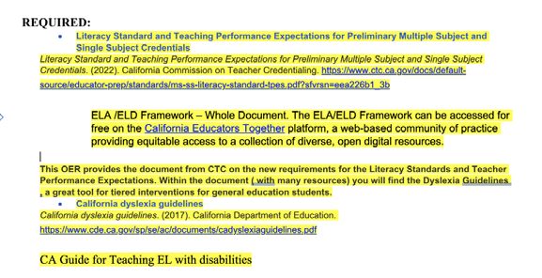
ITL 606 Learners and Learning II | Candidates must read Chapters 6-9 of the Dyslexia Guidelines. See Required Readings pg 2 Chapters 6-9 are listed to be read.  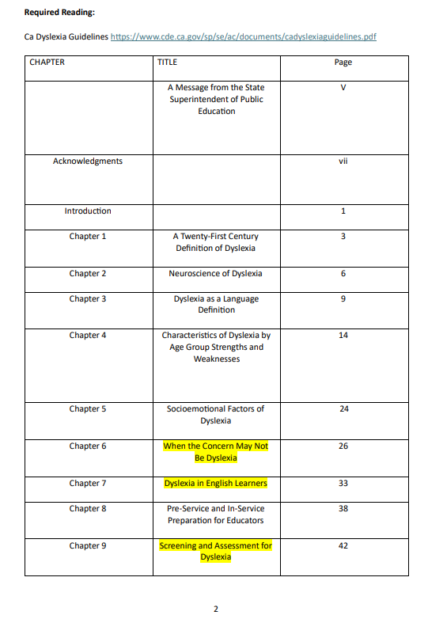
ITL 608 Design and the Process of Teaching | Candidates are to apply the ELD Framework in assignments as well as all chapters of the Dyslexia Guidelines.  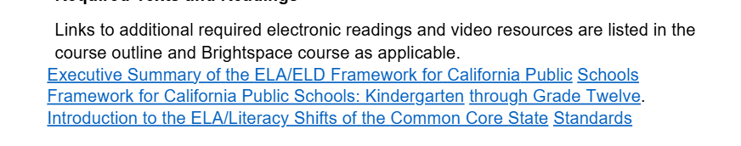  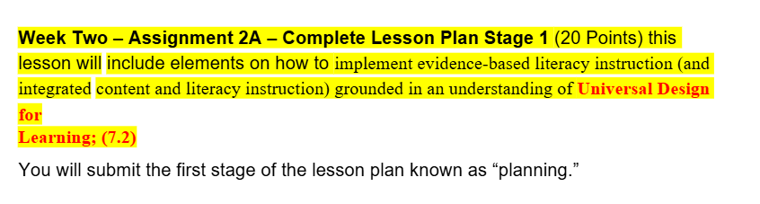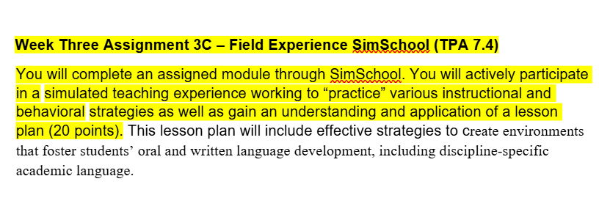
SED 607 Language & Literacy Basics | Page 3 under Required Materials  Pgs. 6-25 in the CLO-TPE-Assignment-Module Alignment Table  Pgs. 24-25 Module 4- Assignment 4b Lesson Plan Assignment  Screenshots from course outline below:  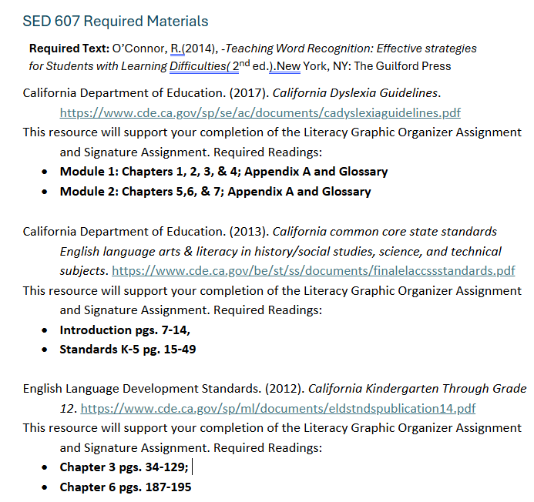  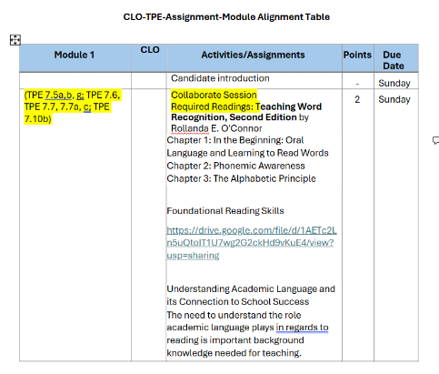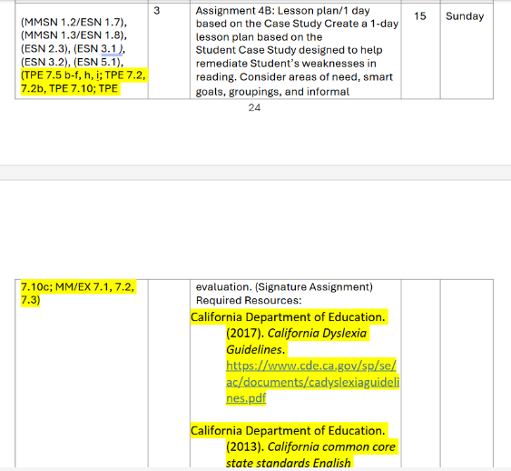
SED 609 Language & Literacy Case Studies | Page 1 Assignments/ Required Readings /Discussion Board/ Lectures & PPT / Text  Page 2 CA Dyslexia Guidelines Chapter 12 highlighted in green  Page 5- CA Dyslexia Guidelines Chapters 2, 3, 9, and 12 highlighted in green  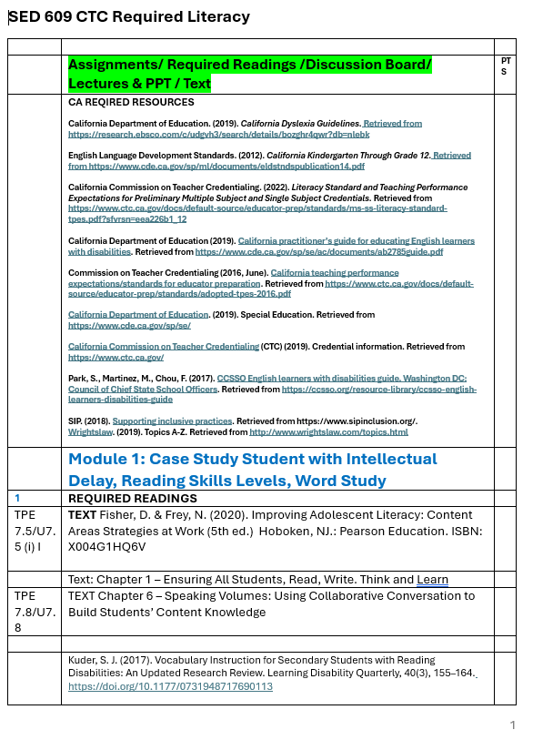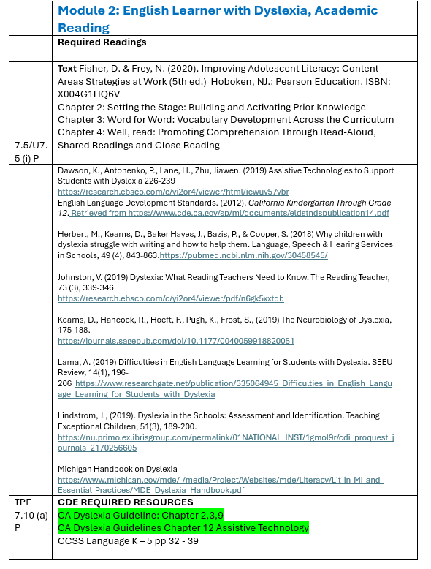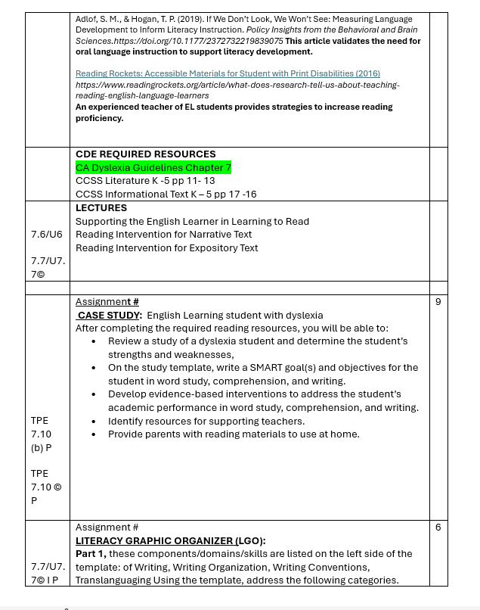
ITL 516 Mathematics Integrative Design | Course Outline, page 4, ELA/ELD resources required.  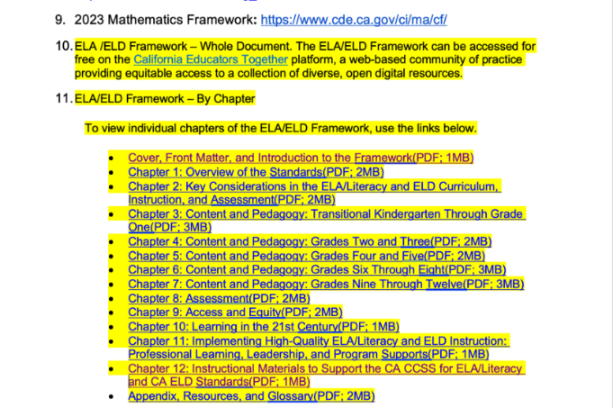

Appendix C Table 3.1. Teaching Performance Expectations: Foundational Skills
Course coverage of Foundational Skills TPE 7.5 with links to specific content within course syllabi.
See Table 3.1 Educational Specialist Extensive Support Needs
See Table 3.1 Educational Specialist Mild/Moderate Support Needs

3.2. Coursework Coverage of Standard 7 – Provide a narrative with links embedded to specific location(s) in course syllabi addressing Standard 7a describing how the program prepares candidates to teach foundational skills and the coverage of the above knowledge and skills (TPE 7.5), as specified in the excerpt from the Education Code. Please be concise. Suggested length no more than 1000 words.
Narrative: The ESN and MMSN SPE programs are designed to equip teacher candidates with the essential skills and knowledge needed to teach foundational literacy skills, as outlined in Standard 7a and TPE 7.5. This narrative highlights the program's alignment with the Education Code and links specific course syllabi to illustrate our approach.

ITL 604: Learners and Learning I Introduce the foundational literacy skills, covering systematic and explicit instruction in phonemic awareness, phonics, and decoding. Candidates learn to integrate these components into effective literacy instruction.
Key Components
- Phonemic Awareness and Phonics: The course emphasizes the critical role of phonemic awareness in reading development. Candidates engage in activities that develop their understanding of phonics and decoding strategies.
- Assessment Practices: Candidates practice and assess their understanding through various methods, including journal article reviews and instructional videos, which are detailed in the syllabus.

SED 607: Language & Literacy Basics
SED 607 focuses on foundational literacy skills, covering systematic and explicit instruction, including phonemic awareness, phonics, decoding, fluency, encoding, and comprehension with a focus on the structured literacy instructional approach. Candidates learn to integrate these components into effective literacy instruction.
Key Components
- Structured Literacy: The course emphasizes the critical role of structured literacy in reading development. Candidates engage in activities that develop their understanding of phonological awareness, phonics and decoding strategies, fluency including practice with decoding text, encoding with dictation practice, vocabulary and comprehension.
- Assessment Practices: Candidates practice and assess their understanding through various methods, including journal article reviews and instructional videos, which are detailed in the syllabus.
- Field Work: Candidates conduct multiple fieldwork assignments including assessing students on all foundational areas of reading, creating a lesson plan and teaching the lesson plan and conducting a self-reflection. Candidates observe instruction in classroom with focus on a foundational reading skills lesson.

SED 609: Language & Literacy Case Studies
Following SED 607, SED 609 builds on the foundational skills learned in the previous course by focusing on practical application and case studies of literacy instruction.
Key Components
- Case Study Analysis: Candidates analyze real-world literacy scenarios, assessing the effectiveness of various instructional strategies.
- Subject Matter Content: Candidates will embed the domains of reading into academic content subjects of English, social studies and math.
- Application in Diverse Contexts: The course prepares candidates to address literacy challenges in diverse classroom settings, ensuring they are equipped to meet all students' needs. More information is available in the course syllabus.

Clinical Practice
In addition to coursework, teacher candidates are required to implement their knowledge in clinical practice. They provide instruction in text reading fluency, which includes:
- Focus on Key Literacy Components: Instruction covers spelling, syllable patterns, semantics, morphology, and syntax, enabling candidates to deliver comprehensive literacy instruction.
- Feedback and Evaluation: Candidates receive feedback based on student teaching evaluations and TPE assessments, ensuring they continuously improve their practices.
Collaborative Professional Development
The TED ITL and SED literacy teams actively collaborate through professional learning communities, which include:
- Research Updates: These communities ensure that teacher candidates are informed of current literacy research, enhancing their instructional practices.
- Ongoing Improvement: Continuous data analysis from student teaching evaluations and CalTPA assessments informs program improvements, ensuring alignment with educational standards and candidate success.

The ESN SPE program prepares teacher candidates to effectively teach foundational literacy skills through a combination of rigorous coursework and hands-on clinical practice. By embedding practical experiences and continuous professional development, we ensure that candidates are well-equipped to meet the diverse literacy needs of their future students.

3.3 *Clinical Practice: Ensuring Opportunities for Candidates to Practice Teaching Foundational Skills – Provide direct links to evidence demonstrating how the program provides opportunities for candidates to practice teaching students foundational reading skills. The standards require that candidates are provided opportunities to practice foundational reading skills that are appropriate for the children and/or students they are teaching in their clinical practice experience. This does not mean that candidates must practice or be observed teaching every individual foundational reading skill in their clinical practice setting (see PSA 24-08). This documentation must include all the following:

3.3a Narrative: District and mentor teachers are notified about clinical practice details and requirements as we secure student teaching and intern placements. The Paid Internship MOU or the Unpaid Student Teaching MOU with districts outlines the expectations for SB488 and Literacy TPE 7. The Partner Notice TPE 7 Literature Assessment/RICA provides the same information candidates received surrounding Partner Notice-PSA 25-03 and is shared with each placement administration (District/School site). The first required virtual “face-to-face” contact is the Triad meeting, and creates a space for the candidate, Site Support Provider (SSP), and University Support Provider (USP) to discuss the upcoming clinical practice details, expectations and assessments. This meeting includes a slide deck outlining opportunities that must be provided to clinical practice candidates and offers a platform to discuss how the SSP and USP will confer to monitor progress, with examples of where evidence of practice may occur. The candidate is included in this meeting as a collaborative planning model and is called on to proactively design focused lessons. An excerpt of the slide deck provides evidence of the focused attention to TPE 7 and Literacy requirements. The handbooks are shared during this meeting, with the expectation that the SSP, USP and Candidate use the resources, including CalTPA Literacy TPE 7, to further guide practices. Additionally, the university support faculty and coaches attended the professional development offered in the spring of 2025 and offer continuous support to the mentor teachers and site administrators during clinical practice.
3.3a Evidence:

The following MOU will be implemented with our district partner as each existing MOU is renewed.
Paid Internship MOU p.2, section 9c
Unpaid Student Teaching MOU MOU p. 4, section 3.14
Triad Meeting Slide deck excerpt
Partner Notice- PSA 25-03
3.3b Narrative: Our current handbooks were launched in a “live” format in Spring 2024. Changes in handbooks regarding literacy elements are updated and will be revised once the approvals are made within this work. The CTC has stated that CalTPA rubrics, and final directions will become available in draft form by mid-July 2025, giving us a few weeks to complete all required updates. A series of Professional Development sessions was completed in Feb 2025 and include instructors, Clinical Practice faculty and District level Partners. The updated handbooks to be revised after feedback from this SB488 report- (University Supervisor Handbook, Site Support Provider Handbook, SED Intern Handbook, and the SED Student Teaching Handbook.
3.3b Evidence:
University Supervisor Handbook

Site Support Provider Handbook

SED Internship Handbook Appendix E Pgs. 40-44

SED Student Teaching Handbook (including Residency programs) Appendix E Pgs. 39-43
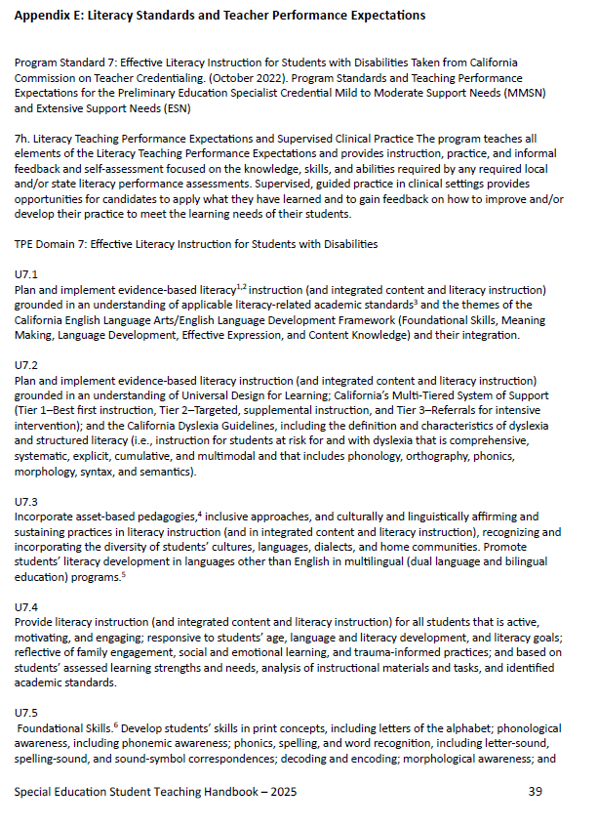

3.3c Narrative: The Sanford College of Education Clinical Practice integrates TPE 7 in weekly coursework and course meetings to support the work of the foundational and method course curriculum. The evidence included presents one tool used by instructors to help candidates plan for lesson design, and where they may include their evidence of TPE 7 in formal Lesson Plans. The assessment of lesson plans occurs within each clinical practice course multiple times as candidates work toward mastery of all TPEs.

3.3c Evidence
TPE 7 Integration into Clinical Practice: Lesson Plan Inclusion Instructional Cycle 2: Extensive Support Needs (ESN) Part B: Learning Segment Template: Detail of TPE 7 Addressing Literacy Standards
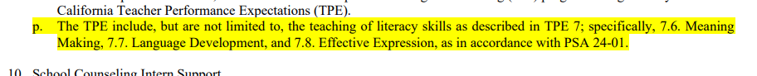

Table 4.1: Strong Literature, Language, and Comprehensive Component with a Balance of Oral and Written Language.
Table 4.1 Educational Specialist Extensive Support Needs
Table 4.1 Educational Specialist Mild/Moderate Support Needs
4.2. Clinical Practice: Ensuring Opportunities for Candidates to Practice a strong literature, language, and comprehension component with a balance of oral and written language. Provide links to evidence demonstrating how the program ensures that candidates are in clinical practice settings that allow them opportunities to practice TPEs related to oral and written language, as applicable to the credential program.

4.2a. Communication/Agreement with Districts
Narrative: Student teachers or Interns in Special Education ESN program are guided by the current California Teacher Performance Expectations (TPE) in the agreement that all students must sign.
4.2a Evidence:
Unpaid Student Teaching MOU- See p. 4; section 3.14 letter i; highlighted in yellow (screenshot)
Paid Internship MOU- See p.3 letter p; highlighted in yellow (screenshot)

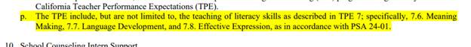
4.2b. Candidate Information
Narrative: The Special Education Clinical Practice Lesson Plan (page 1 and page 5) as well as the Special Education Clinical Practice Handbooks for Student Teaching (including Residency programs) and Internship Clinical Practice clearly depict the CA Literacy Standards in Appendix E of both handbooks.
4.2b Evidence:
SED Intern Handbook Appendix E p. 40-44
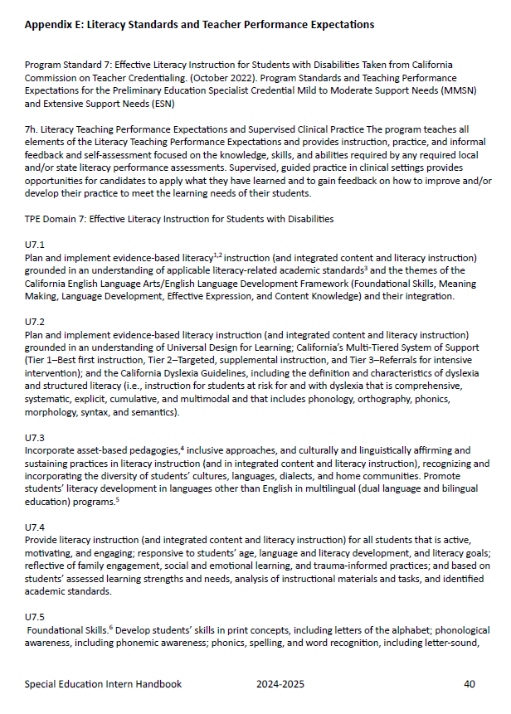

SED Student Teaching Handbook- Appendix E p. 39-43
SED MMSN and ESN Lesson Plan see p. 1 and p. 5 of lesson plan
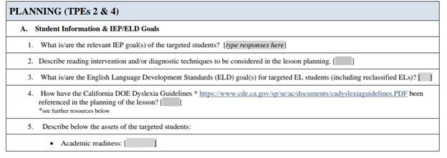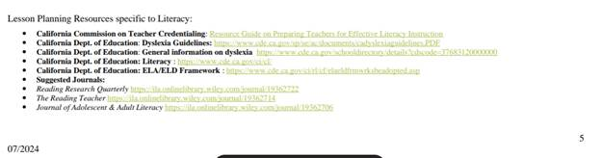
4.2c. Candidate Clinical Practice Opportunities
Narrative: The Sanford College of Education Clinical Practice integrates TPE 7 in weekly coursework and course meetings to support the work of the foundational and method course curriculum. The evidence included presents one tool used by instructors to help candidates plan for lesson design, and where they may include their evidence of TPE 7 in formal Lesson Plans. The assessment of lesson plans occurs within each clinical practice course multiple times as candidates work toward mastery of all TPEs.
4.2c Evidence:
SED MMSN and ESN Lesson Plan

Screenshot: 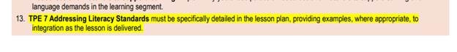

Table 5.1. Ongoing diagnostic techniques that inform teaching and assessment, early intervention techniques
See Table 5.1 pgs. 1-7 Educational Specialist, Extensive Support Needs
See Table 5.1 Educational Specialist - Mild/Moderate Support Needs

All Preliminary Education Specialist: Mild to Moderate Support Needs and Extensive Support Needs programs must complete the following additional tables as appropriate to the credential offered.
See Table 5.1 Additional Required Table starting on p. 8 in the ESN Table 5.1
See Table 5.1 Additional Required Table starting on p. 6 in the MMSN Table 5.1

5.2. Clinical Practice Opportunities for candidates to learn about diagnostic techniques that inform teaching and assessment and early intervention techniques.
Narrative: Candidates receive multiple opportunities to practice skills and receive formative feedback through lesson plans, weekly activities, and formal observations. These practices ensure continuous improvement and targeted support aligned with the TPEs, including TPE 7.
Lesson Planning: Before each observation, candidates submit lesson plans and receive verbal and written feedback from both their School Site Provider (SSP) and University Support Provider (USP). Candidates revise their lesson plans based on this coaching, followed by a discussion before lesson delivery. Lesson planning emphasizes the application of diagnostic techniques, early intervention strategies, and best practices for teaching and assessment, guided by two mentors.
Weekly Activities: Candidates complete weekly activities aligned to the TPEs, including TPE 7. At midpoint, candidates conduct a self-evaluation running record of their TPE progress, collaboratively review it with their SSP, and select a target area for focused growth.
Observations: Candidates are formally observed seven times during Clinical Practice:
- Clinical Practice A (ESN 655/657): Four observations with coaching and feedback on planning, delivery, and lesson analysis. The fourth observation includes a formative assessment to prepare for Clinical Practice B.
- Clinical Practice B: Three additional observations with annotations, reflections, and assessments, culminating in a final (seventh) observation that includes a summative assessment.
The summative assessment supports the Individual Development Plan (IDP) discussion among the candidate, SSP, and USP, preparing the candidate for transition into a district-employed, credentialed teaching role.
All activities, evaluations, and observations now explicitly integrate TPE 7.
5.2a. Direct link to location(s) in sample MOU(s)

Narrative: The following MOU will be implemented with our district partner as each existing MOU is renewed.
5.2a Evidence:
Paid Internship MOU see p.2; 9a (screenshot below)

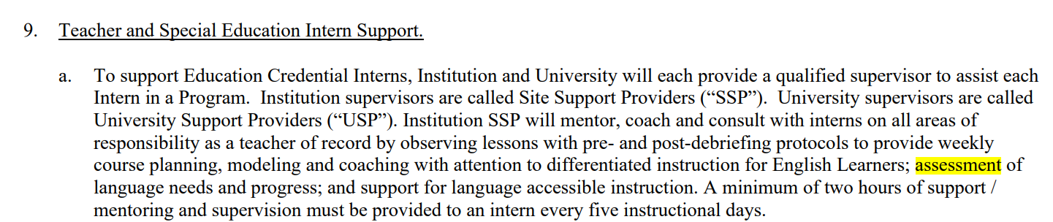

Unpaid Student Teaching MOU see p. 2; section 3.1
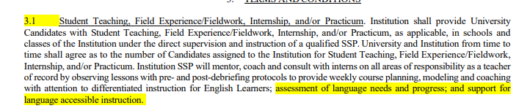

5.2b. Links to specific location(s) in candidate handbooks or materials that describe for candidates what is expected of them with respect to learning about diagnostic techniques as well as early intervention techniques.

Narrative: The Special Education TPE Running Record that all candidates are required to enter weekly. Candidates enter weekly evidence to document how each TPE is being met. Candidates collaborate with their SSPs to plan experiences that will fulfill each TPE. Entries should provide sufficient detail to make a clear connection between the entry and the TPE. The USP will include evidence from this document as part of the end-of-course Assessment. Specific diagnostic assessment information is found on pages 9-11 of the ESN Running Record and pages 10-13 of the MMSN Running Record. This is pictured below along with the link to the documents.
5.2b Evidence:
ESN Running Record
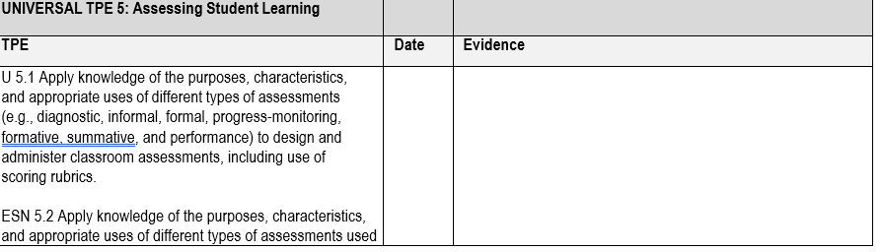
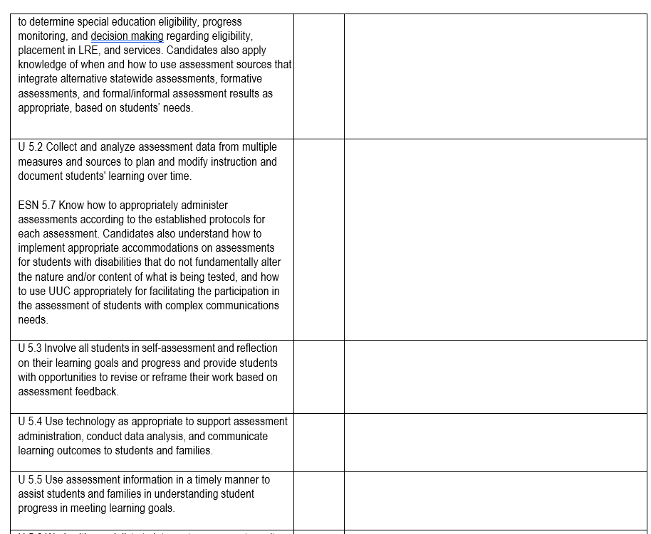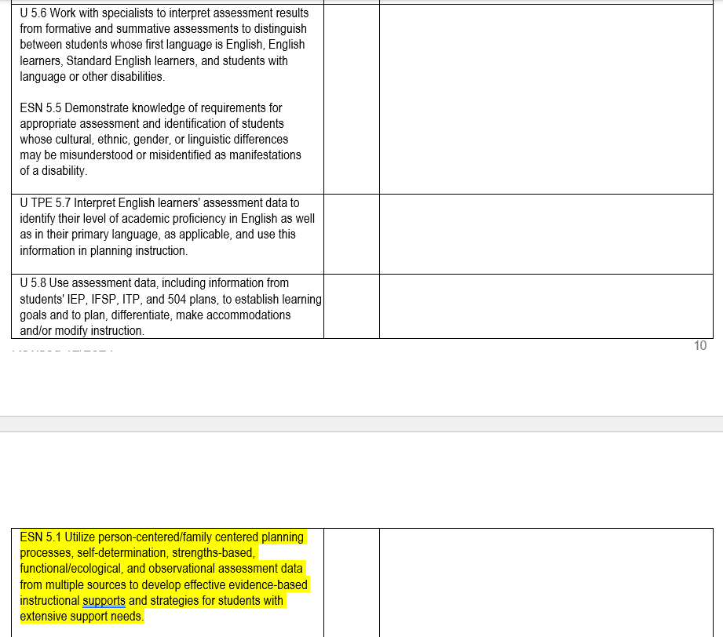

MMSN Running Record
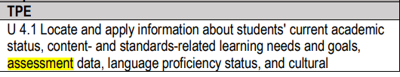
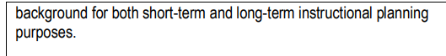
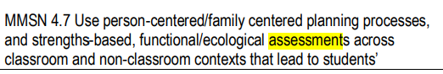
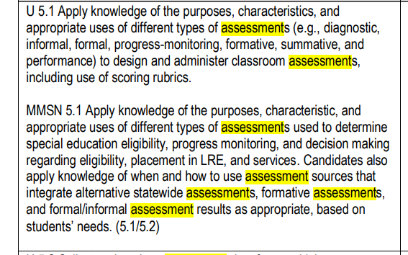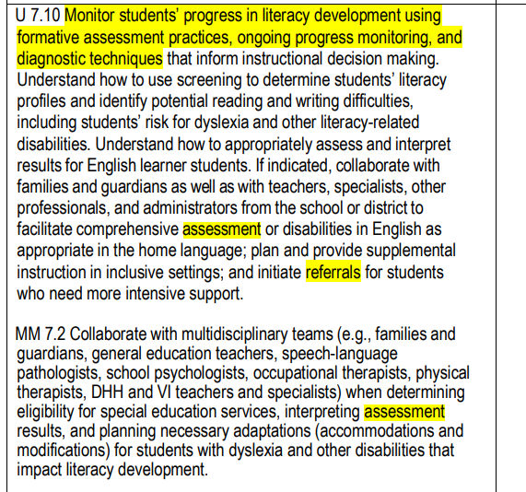
5.2c. Links to specific evidence showing how candidates are provided opportunities to learn about and, where possible, observe how schools/teachers are using screening and diagnostic techniques to inform teaching and assessment and early intervention techniques, as appropriate to the credential and as identified in the TPEs and standard.

Narrative: The Sanford College of Education Clinical Practice integrates TPE 7 in weekly coursework and course meetings to support the work of the foundational and method course curriculum. The evidence included presents one tool used by instructors to help candidates plan for lesson design, and where they may include their evidence of TPE 7 in formal Lesson Plans and in the TPE Running Records for both ESN and MMSN. The assessment of lesson plans occurs within each clinical practice course multiple times as candidates work toward mastery of all TPEs.

5.2c Evidence:
SED MMSN and ESN Lesson Plan see p. 1: Direction #4, #11; and corresponding sections of Learning Segment Overview: Specific to TPE 7

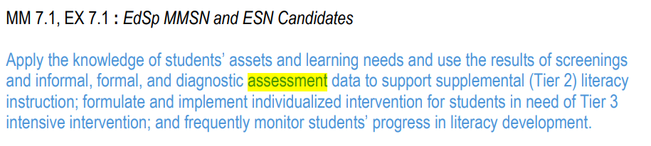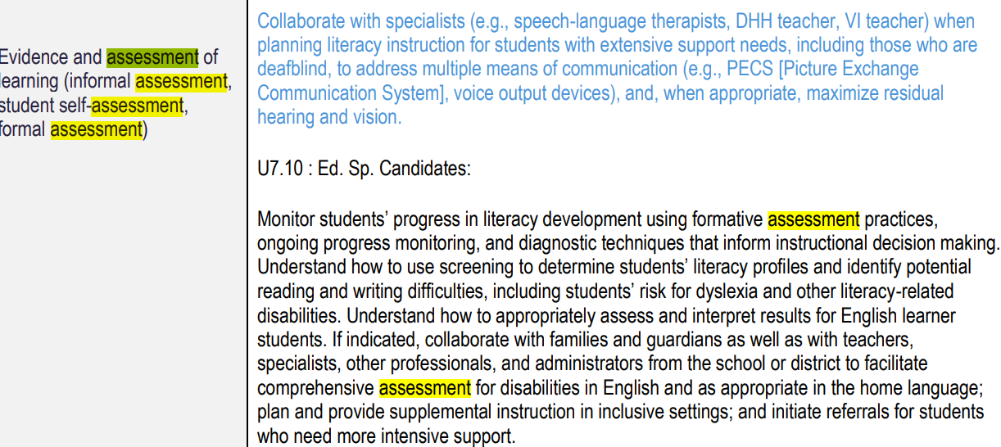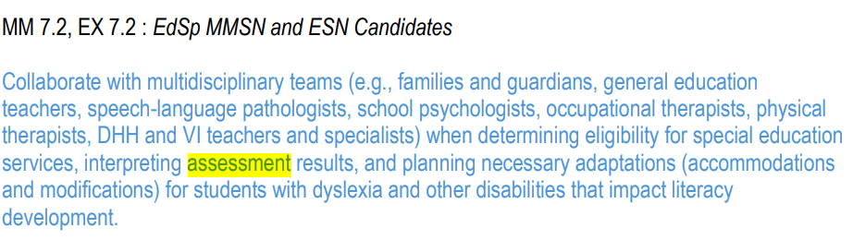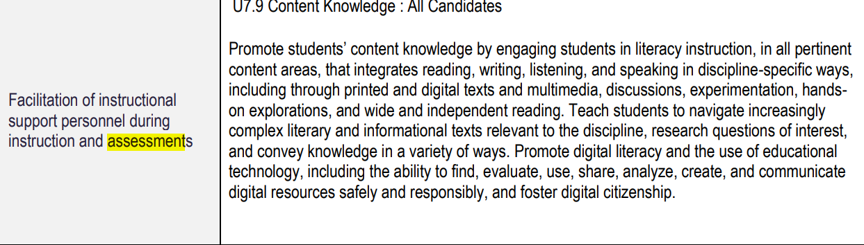

ESN Running Record pgs.14, 15, and 16
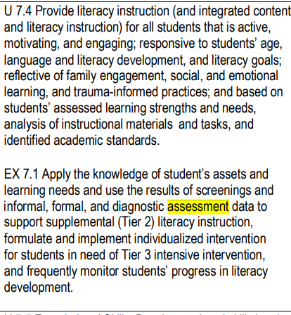
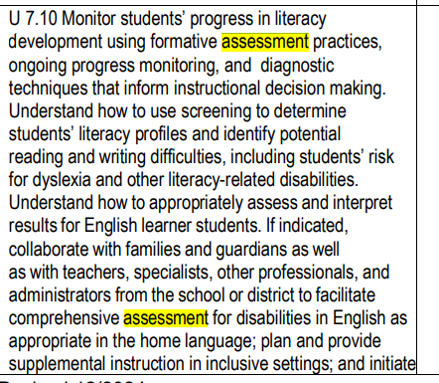
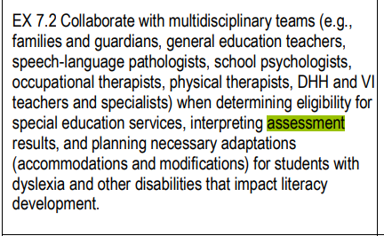

MMSN Running Record pgs. 10-13
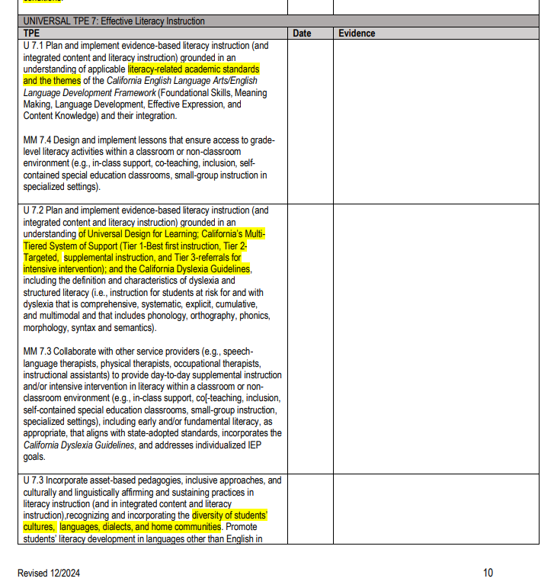

5.3 Incorporation of California Dyslexia
Narrative: The California Dyslexia Guidelines are integrated into multiple courses where teacher candidates can build foundational knowledge, implement best practices and receive assessment feedback from faculty.
Guidelines 5.3a. Coursework – Explain how the California Dyslexia Guidelines are incorporated into the program for all candidates. (300 words or less).
Narrative: The Commission on Teacher Credentialing (CTC) awarded a Dyslexia Grant to the Department of Teacher Education and the Department of Special Education at SCOE for the period of July 1, 2022, to June 30, 2023. In a collaborative effort, both departments developed a series of dyslexia-related modules and curated evidence-based resources to enhance the teacher preparation programs. These modules and resources were designed to improve candidates' understanding of dyslexia and its implications for classroom instruction and were integrated into several courses within the curriculum. In addition, the Special Education Department has been proactive in the development of courses for Education Specialist candidates which address the identification, assessment, and interventions for students with dyslexia. The SED 607 Language and Literacy Basics and SED 609 Language and Literacy Case Studies are part of the Extensive Support Needs program. In SED 607, dyslexia is addressed within the content area of reading screening and assessment. Specific content knowledge of dyslexia is part of the content available for special education teachers and further developed in SED 609. An entire course section is dedicated to the discussion regarding identification, assessment, and intervention using a Structured Language and Multisensory Intervention (CA Dyslexia Guidelines p, 64.) The course also requires the candidates to explore Assistive Technology to support students with dyslexia as identified in the Guidelines. The assignment requires the candidates to develop a technology toolkit specific for the student in the case study. Further, a weekly Literacy Graphic Organizer is presented which addresses each of the domains in reading from the Literacy TPE (CTC, 2019) and addresses the areas of AAC option for students with disabilities.
5.3a Evidence:
SED 607 Language & Literacy Basics
SED 609 Language & Literacy Case Studies
5.3b. Coursework – Provide direct link(s) to specific location(s) in course syllabi where the content of the California Dyslexia Guidelines is clearly identified.
Narrative: Candidates are introduced to Dyslexia early in the program in ITL 604 which is part of the common trunk with TED. Candidates review the Introduction to Dyslexia Module, then they work respond to prompts on the fundamental elements of the California Dyslexia Guidelines.
Candidates have further opportunities to practice and be assessed on the application of the Dyslexia Guidelines in ITL 606, ITL 608, SED 607, and SED 609.
5.3b Evidence:
ITL 604 Read the ELD framework: Chapter 1, respond to the prompts about their understanding in a journal response, and continue collecting definitions for the Glossary in their reflections.
ITL 606 Read Chapters 6-9 Dyslexia Guidelines; Assignment 2B
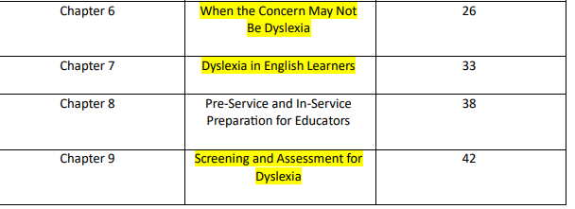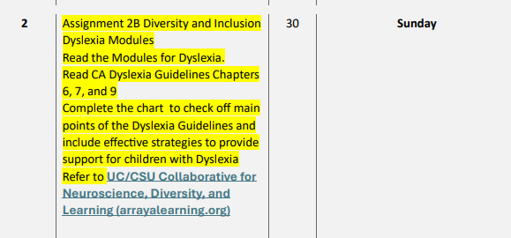

ITL 608 Design and the Process of Teaching
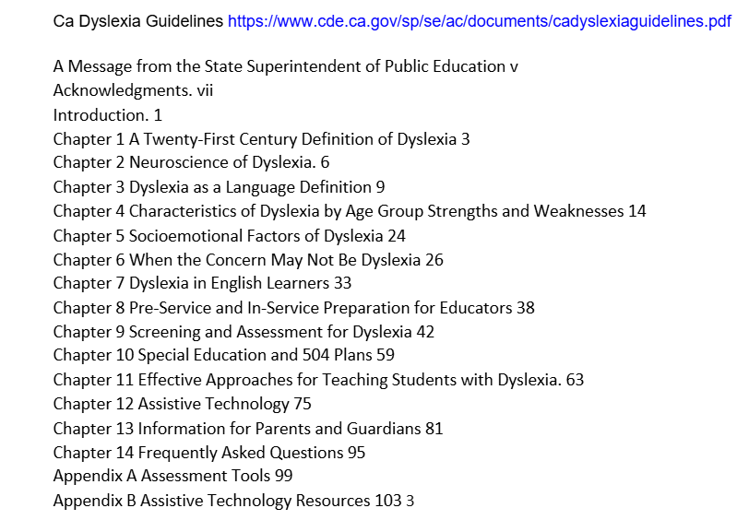
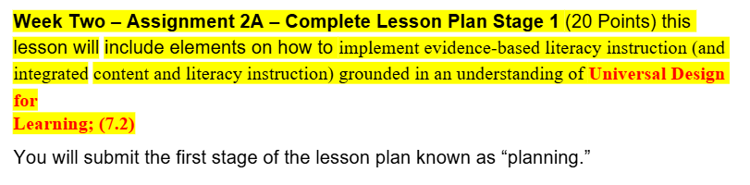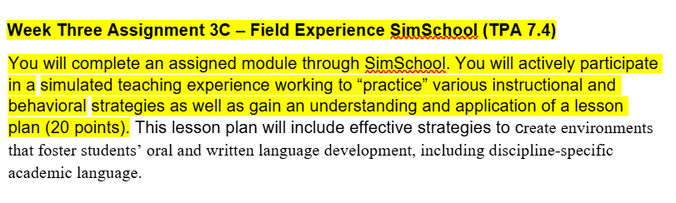

SED 607 Language & Literacy Basics Page 3 under Required Materials
Pgs. 6-23 in the CLO-TPE-Assignment-Module Alignment Table
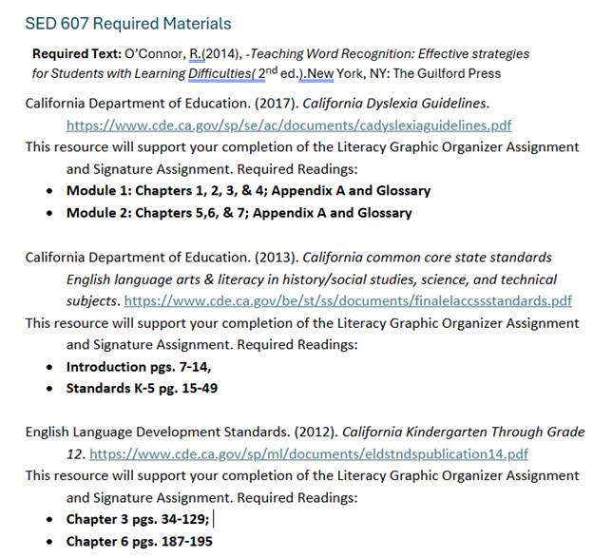
SED 609 Language & Literacy Case Studies- Page 1 Assignments/ Required Readings /Discussion Board/ Lectures & PPT / Text
Page 2 CA Dyslexia Guidelines Chapter 12 highlighted in green
Page 5- CA Dyslexia Guidelines Chapters 2, 3, 9, and 12 highlighted in green
Page 7 CA Dyslexia Guidelines Chapter 7 highlighted in green
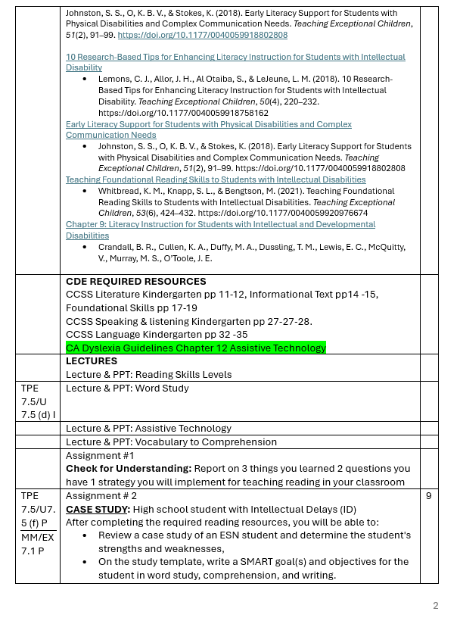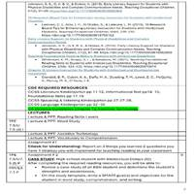
5.3c. Clinical Practice Explain how the program provides, to the extent practicable, opportunities for candidates in clinical practice settings to observe and practice the concepts and strategies included in the California Dyslexia Guidelines.

Narrative: This is addressed in the Lesson Plan, allowing candidates serving K-12 students with dyslexia to be provided an opportunity to use the lesson plan to observe and practice the concepts included in the CA Dyslexia Guidelines.
5.3c Evidence:
SED MMSN and ESN Lesson Plan p. 2; Content Standards, Curriculum Frameworks, and/or Core Content Connectors; sections throughout lesson plan template
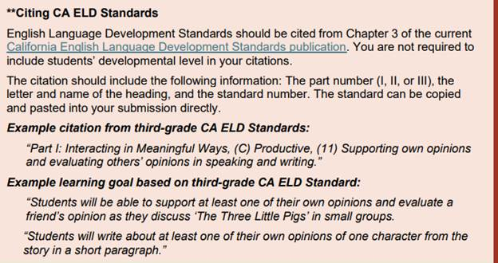
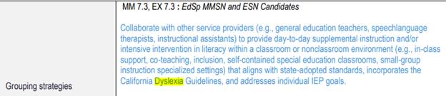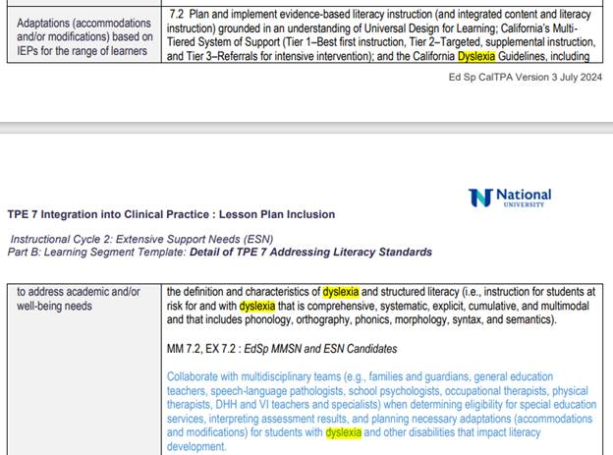
5.3d. Communication/Agreement with Districts – Direct link(s) to sample MOU(s) or other documentation describing expectations for clinical practice settings related to providing, to the extent practica.
Narrative: The following MOU will be implemented with our district partner as each existing MOU is renewed.
5.3d Evidence:
Paid Internship MOU
Unpaid Student Teaching MOU
5.3e. Candidate Information – Direct link(s) to location(s) in candidate handbooks or other candidate material that explains the program expectations around the California Dyslexia Guidelines.
Narrative: Our current handbooks launched in a “live” format in Spring 2024. Changes in handbooks regarding literacy elements are in draft format and will be updated once the approvals are made within this work. A series of Professional Development sessions are planned for January 2025 and will include Instructors, Clinical Practice faculty and District level Partners. The updated handbooks to be revised after feedback from this SB488 report- (University Supervisor Handbook, Site Support Provider Handbook, SED Intern Handbook, and the SED Student Teaching Handbook.
5.3e Evidence:
University Supervisor Handbook
SED Intern Handbook Appendix E Pgs. 40-44
SED Student Teaching Handbook Appendix E Pgs. 39-43
University Site Support Provider Handbook
5.3f. Provide direct links to specific evidence showing how candidates are provided opportunities to learn about and, where possible, observe how schools/teachers use the skills described in California Dyslexia Guidelines (may be combined with 5.3c above).
Narrative: The eLearning modules created by UC/CSU Collaborative for Dyslexia were shared on 9/18/24 in a webinar that the chair attended. To meet this guideline, the SED 607 and SED 609 have embedded them into coursework along with other strategies.
5.3f Evidence:
UC/CSU Collaborative for Neuroscience, Diversity, and Learning (arrayalearning.org)
E-Learning Modules – UC/CSU California Collaborative for Neurodiversity and Learning (ucla.edu)

