ATAM Coordinator Orientation
Name: Type in your first & last name Student ID: Enter your nine-digit number.
Today’s Date: Pick today’s date. SAS Accommodation Letter: Effective date.
Today’s Goal(s): Survey student’s technology use. Anticipate alt format preference.
COURSE OF STUDY: Select your current standing.
Declared major: Type in your degree goal. College: Select from dropdown list.
NEAREST NU CAMPUS: NU location of your academic adviser.
EMAIL ADDRESS(es): Type in your preferred email.
Phone Number: Cellular phone to call you.
PREPARATION for term: 1707 – July 10 to August 5 (four-week duration)
Course: Enter the title of your course.
Professor: What is your current professor’s name?
QUESTIONS:
- What tech devices do you use in your everyday life?
  - Select your current computing platform: Operating System Software.
  - Carry any mobile devices: Tablet, eReader or smartphone model.
- Have you had any issues with using the required technology in NU (e.g., Blackboard Learn 9.2, SOAR Student Portal, other Publisher curriculum website?
- What assistive technology (AT) have you tried before? What worked, what did not, and why? Mention your specialized hardware and software, assistive devices for educational use.

What alternate media preferred format(s) do you typically request?
☐Electronic Text: PDF, TXT, DOCX, RTF, HTML, MathML, ePUB, other __________________
☐Large print— Font Style: _____________ Font Size: ______, Paper size: _______________
☐Audio: DAISY, MP3, WAV
☐ Tactile Graphic ☐Braille (digital / embossed) Grade ____
- Have details of the required textbook for the Alternate Media Production Request form?
ISBN: __ Author (LN): Title:
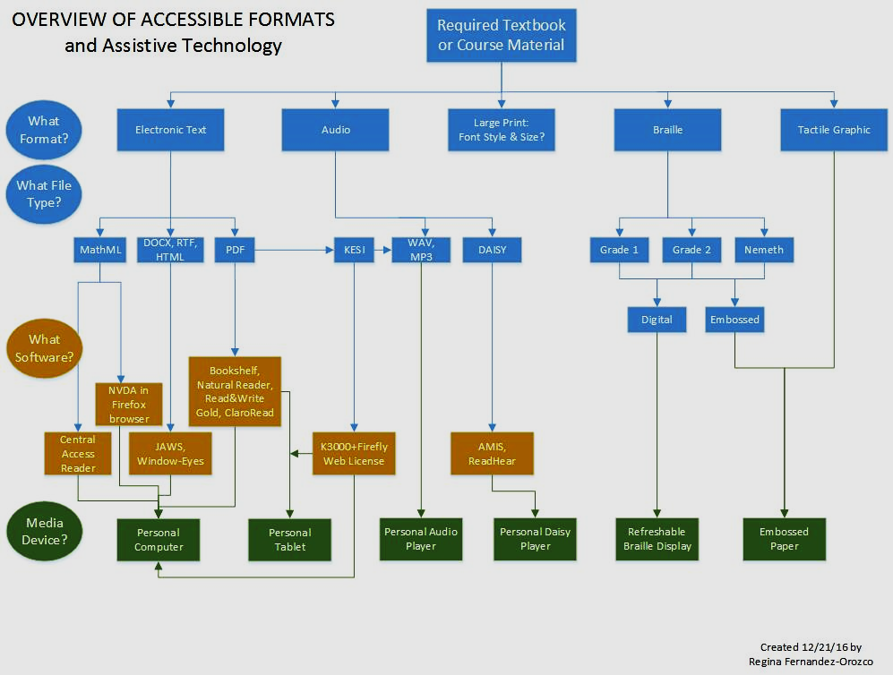

STUDENT ACCESSIBILITY SERVICES
16875 West Bernardo Drive Suite 110
San Diego, CA 92127-1675
www.nu.edu/sas

Alternate Media (AM) Service Terms & Conditions
- Eligibility of AM services will be determined by the assigned Accessibility Services Coordinator and is based in part by certified medical documentation provided by the student. If you are not currently registered with Student Accessibility Services, please visit our website to learn about available services and complete an application.
- AM services need to be requested EACH TERM and for EACH TEXTBOOK, ARTICLE, OR OTHER PRINT MATERIAL. A complete AM Request Form is required before any material is provided in alternate format(s).
- Students requesting course materials in alternate formats must provide the Assistive Technology/Alternate Media (ATAM) Coordinator with proof of ownership of the course materials in the form of a purchase receipt or an affidavit of ownership before alternately formatted course material is to be distributed to the student.
- Requests for alternately formatted course material(s) will be provided on a case‐by‐case basis. The ATAM Coordinator will make every reasonable effort to provide AM services in the student’s preferred format; however, due to limited time and resources specific to course restraints the ATAM Coordinator reserves the right to provide AM in other formats to ensure timely provision.
- AM Request Forms must be submitted to the ATAM Coordinator in accordance to the AM timeline for AM requests (see paragraph 6). Failure to comply with established deadlines will result in the provision of AM requests at the discretion of the ATAM Coordinator. All AM production and distribution will be conducted as quickly as possible with priority given to required materials. For timely conversion of non-required materials which are otherwise related to a student’s educational goals, the student must provide the ATAM Coordinator access to or the actual print/media to be converted.
- AM production takes time and requires up to (6) six weeks to complete and distribute required course materials to the student. The ATAM Coordinator will make every reasonable effort to provide AM requests in this time period. Non-required materials which are otherwise related to a student’s educational goals (ex., optional, recommended, or research for a required assignment) require up to (8) eight weeks to complete and distribute. Finally, in the case of Braille a minimum of (12) twelve weeks’ notice is necessary.
- The course material provided in alternate format(s) is for sole use by the SAS student who makes the AM request. Students receiving AM services are not permitted to reproduce and/or distribute alternate media provided. Any unauthorized reproduction and/or distribution of AM requests may result in either disciplinary action by National University or outside regulatory agencies.
- Any questions, comments, concerns, and/or suggestions regarding AM services are to be directed to the ATAM Coordinator who may be contacted by phone at 858-309-3436 or via email at accessiblemedia@nu.edu. Alternatively, you may contact the SAS Manager at 858-521-3912 or via email at jrobinson2@nu.edu.
By signing below, I have read and agree to terms of this Conversion/Alternate Media Agreement form.
Signature Student ID Date

