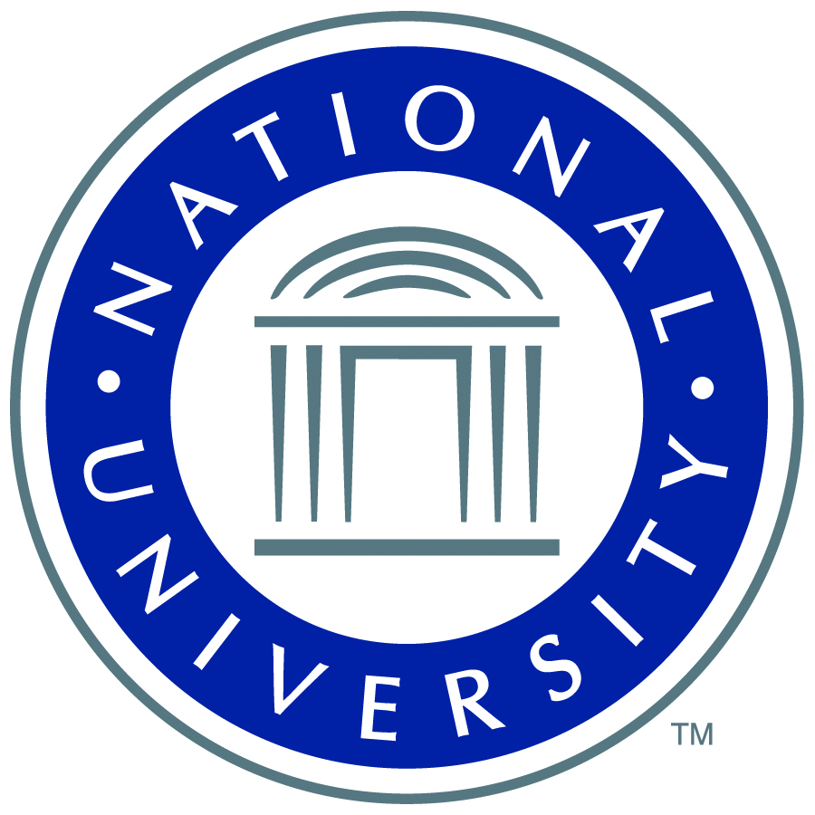

Dear Community Leader,

There are more than 22 million military veterans in the United States, including more than 1.9 million in California—your friends, neighbors, and family. It is critical to provide the resources that veterans need to help them transition to and succeed in civilian life. For decades, National University has helped answer that call, with its programs centered on providing for the educational needs of active duty military and veteran students.

A recipient of the Ray Ehrensberger Award for Excellence in Military Education, National University continues to take considerable strides in making education accessible and relevant to our country's military. At National University’s Center of Excellence for Veteran Student Success, programming focuses on easing veterans’ transition to campus life, increasing retention, achieving educational and career goals, and providing a higher quality of life. With nine on-base learning centers in San Diego alone, National University is the leader among local universities in educating active duty military and veterans with enrollment currently exceeding 6,000—all at discounted tuition rates.

Still, with more than one million veterans currently unemployed, the need for quality education is vital and we are compelled to significantly increase opportunities to educate and ensure civilian success for those who served. To this end, National University is establishing a scholarship program to benefit its veteran students, to be funded by “Visionary Voices, A Tribute to our Veterans,” the inaugural fundraising dinner which we are honored to chair on October 27, 2012 at the San Diego Marriott Marquis & Marina. We believe that you share this same passion for helping the military veterans in our community, and for this reason we invite you to join this effort as a sponsor.

Since 1971, National University has been committed to providing education that is accessible, challenging, and relevant to a diverse student population. As a nonprofit institution, National University invests in its students by offering quality instruction and technologies, and superior faculty and student services to meet the emerging demands for education in the 21st century.

You have the opportunity to support our troops by giving veterans the gratitude they deserve in the form of something priceless—education. The benefits outlined in the enclosed sponsorship packet will provide visibility for your organization as a partner in this noble effort.

On behalf of National University, we thank you for your generosity and look forward to your partnership in our cooperative efforts in San Diego and beyond.


Best Regards,


RADM Ronne Froman Linden Blue
United States Navy (Ret.) General Atomics
2012 Dinner Co-Chair 2012 Dinner Co-Chair

